Who can I contact for help locally?
Mental Health Association of Allegheny County:
- An organization dedicated to individuals have mental disorders
1945 Fifth Avenue 3rd Floor Pittsburgh, PA 15219-5543
Phone: 1-412-391-3820
Toll Free: 1-877-391-3820 Email: mha@mhaac.net Website: http://www.mhaac.net
What books are available for parents?
Facing Panic: Self-Help for People with Panic Attacks by R. Reid Wilson, PhD: Provides 7 self-help strategies for breaking the cycle of panic. Order the book directly by going to http://www.adaa.org/
I Don’t Want To Be Crazy by Samantha Schutz: Gripping firsthand account of a college freshman’s struggle to cope with panic attacks
Related books:
- How to Help Your Loved One Recover from Agoraphobia by Karen P. Williams
Shared Confinement: Healing Options for You and the Agoraphobic in Your Life by Robert C. Chope, PhD
Where can I find useful information online?
The websites below will provide you and your child information related to therapists, support groups, self tests, and stories of hope.
American Psychological Association: http://www.apa.org
Anxiety Disorders Association of America (ADAA): http://www.adaa.org/
Mental Health America: http://www.mentalhealthamerica.net
MentalHelp.net: http://www.mentalhelp.net/
National Institute of Mental Health (NIMH): http://www.nimh.nih.gov/ You can also call 1-866-615-6464 to obtain more information about Panic Disorder.

There is help, and there is hope!


Does your son or daughter experience sudden surges of overwhelming fear for no apparent reason?

It could be a serious, but treatable condition

Look inside for help!

What is Panic Disorder?
- It is a real condition involving recurrent, unexpected bursts of extreme terror, called panic attacks, followed by at least 1 month of frequent fear of having another attack, worry over the attacks’ effects, or major behavior changes to decrease future attacks.
Who has Panic Disorder?
- Approximately 1 in 75 people (roughly 2.4 million Americans)
- Typically older adolescents & young adults (usually 18 to 24 years old)
- 2 out of 3 people with it are female
Is my child living with it?
ASK YOURSELF THE FOLLOWING?
- Does my child have repeated episodes involving at least 4 of the symptoms below?
A feeling of imminent danger or doom, the need to escape, accelerated heart rate, sweating, trembling, shortness of breath, a choking feeling, chest pain, nausea or stomach discomfort, dizziness or lightheadedness, feeling detached or unreal, fear of dying, numbness or tingling, chills or hot flushes

- Has my child recently undergone a major life transition, or is he/she experiencing increased stress?
- Has another family member ever suffered from Panic Disorder?
If you answered “yes,” WHAT NOW?
Take action through the proper steps:
- Contact your doctor and/or a licensed therapist
- Ask about available treatment
ONLY 1 IN 4 PEOPLE WITH PANIC DISORDER RECEIVE TREATMENT!
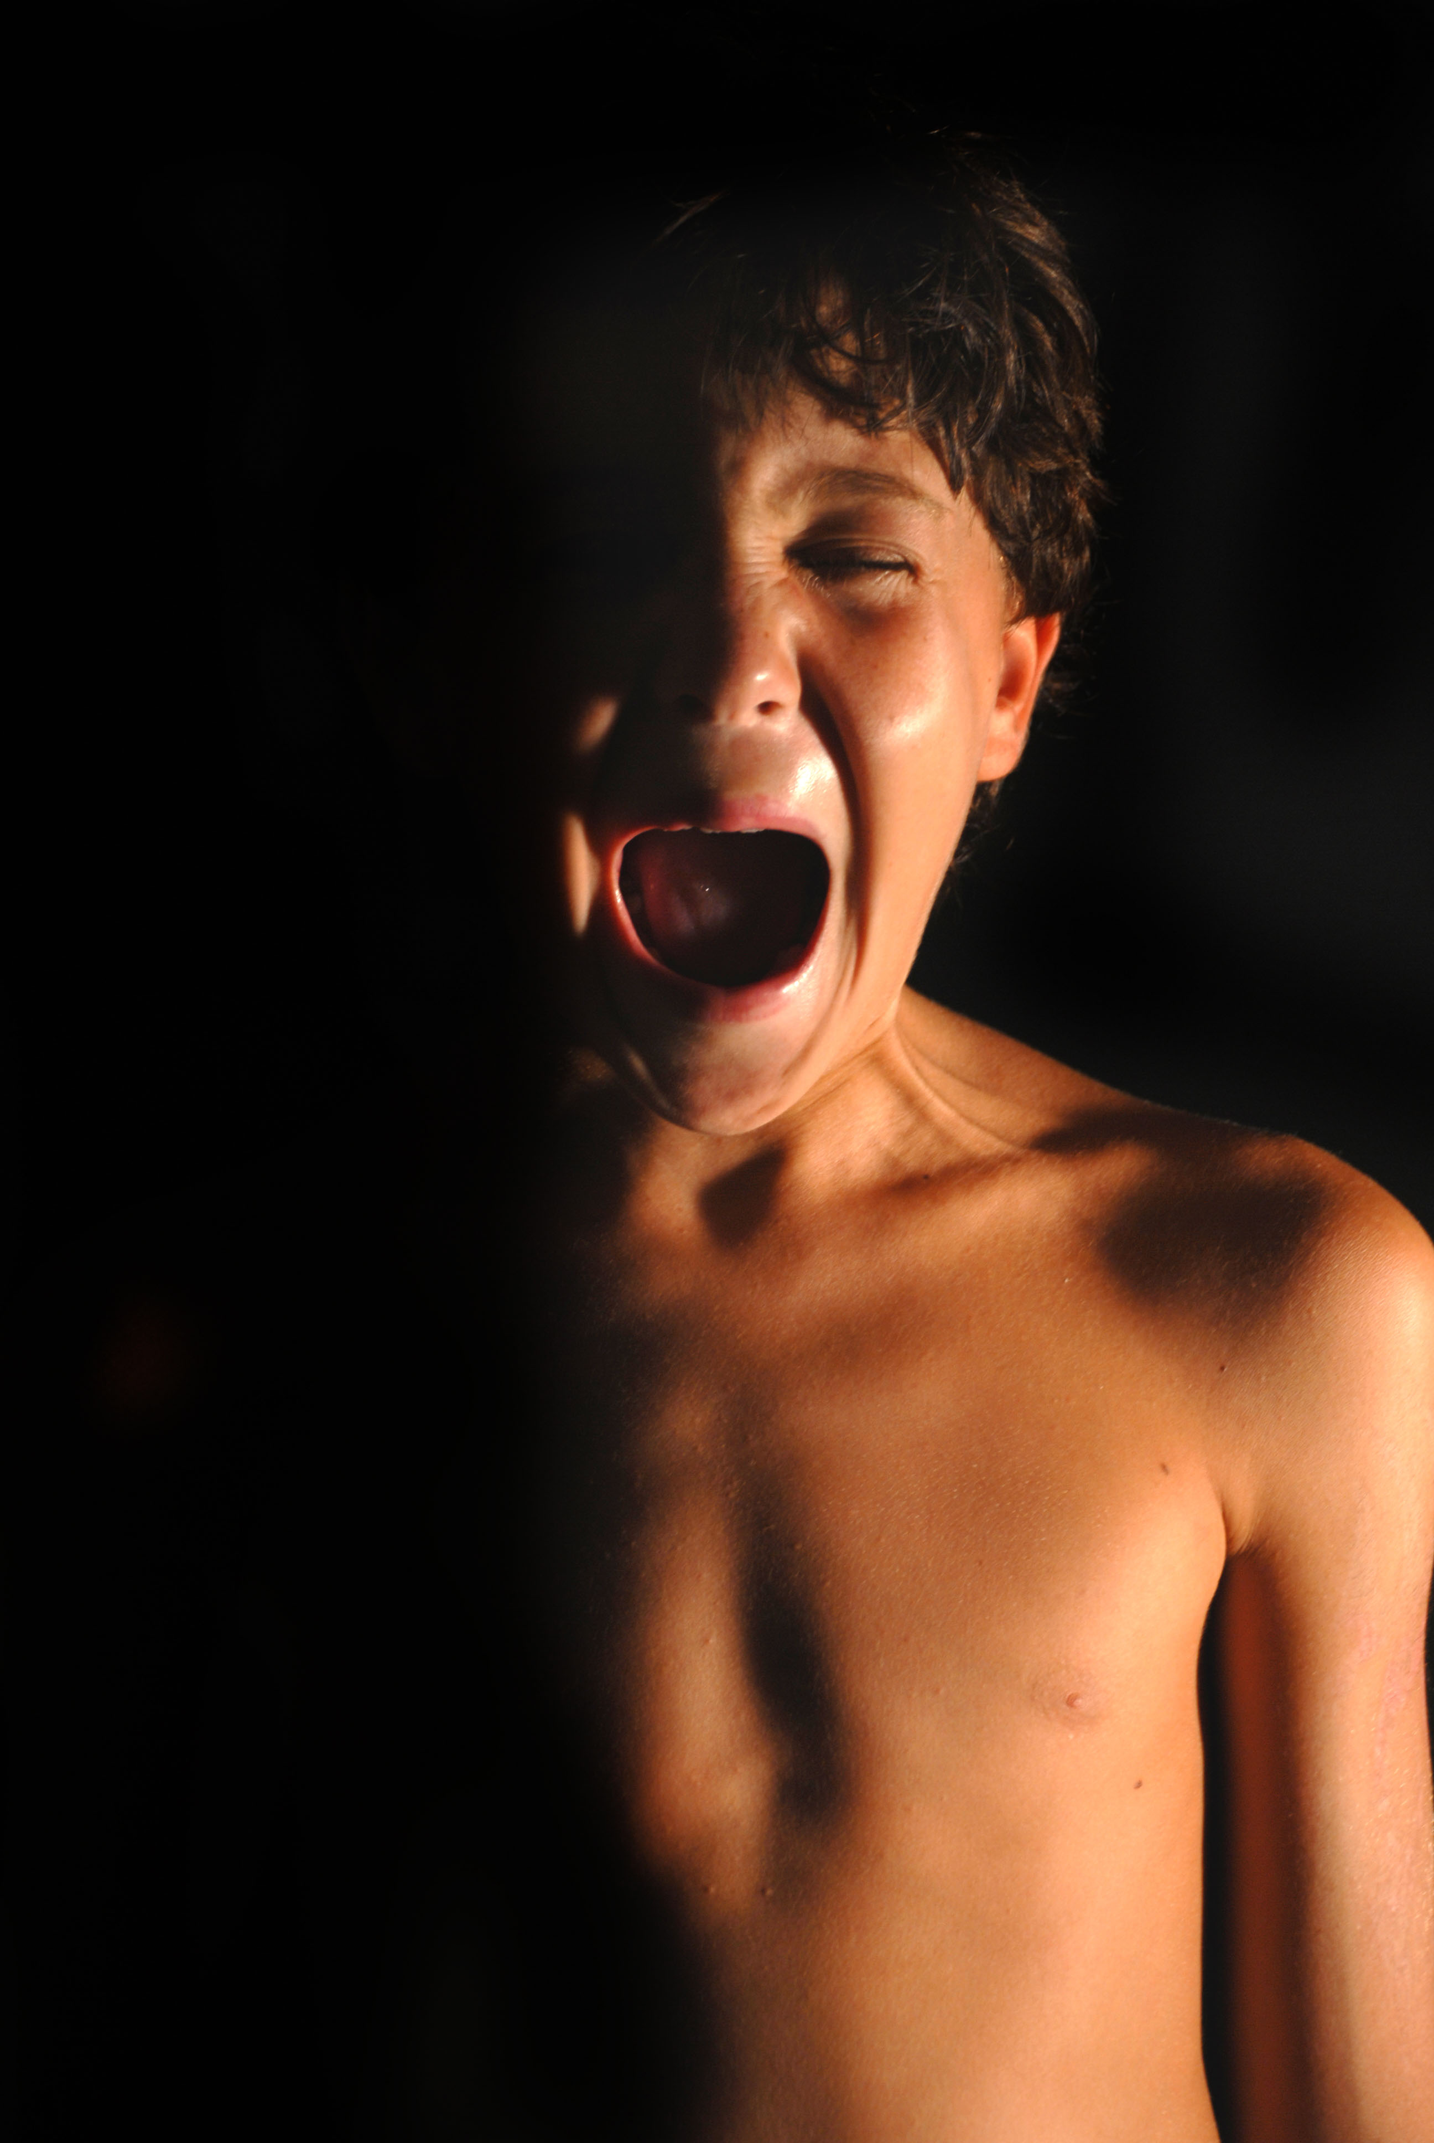
Without proper treatment, your child may face drastic consequences, such as:
1. Developing phobias (Your child may avoid situations or places where he/she has experienced an attack (like school, stores, or even all public places!)
2. Agoraphobia—basically a fear of being in public places. This can put your child at an increased risk of also suffering from depression.
3. An increased risk of suicide and alcohol and/or drug abuse
Your child can lead a NORMAL LIFE, but only if treatment is pursued. Remember, he/she is NOT ALONE!
What treatments are available?
Mental health professionals tend to utilize 2 broad approaches:
Therapy
- Cognitive therapy – This method teaches your child to recognize and understand what “triggers” an attack. This understanding would then lead to a new way of thinking prior to the onset of an attack.
- Behavior therapy – This method includes a combination of techniques like relaxation training (i.e. breathing exercises) and systematic, progressive exposure to anxiety-producing situations.
Medication (prescribed by a doctor) – Possibly anti-anxiety medication or anti-depressants
Although Panic Disorder can persist for several months or for many years, the above treatments are extremely effective!
What can I do to help?
Seek out the right people AND the right treatment. Take these steps, and you will help your child lead a healthier life.

-

